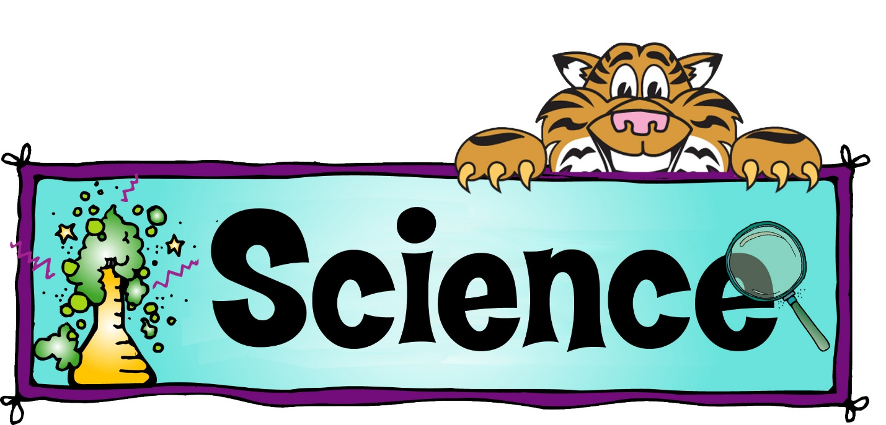
7th Grade Science Syllabus
Course Description:
7th Grade Science begins to look at complex scientific principles. In order to teach these concepts effectively, the curriculum will include a combination of hands-on labs and traditional classroom instruction. This course covers basic Physics, Geology, and introduces Life Science. The textbook used for this course in Indiana Science Fusion which includes the following Units: Nature of Science, Motion and Forces, Energy, Earth’s Structures, The Changing Earth, and The Cell. (Scope and Sequence attached separately)
Materials:
The following materials are expected to accompany you to class every day:
- Three-Ring Binder containing your syllabus, homework that has been passed back and unit tests.
- Indiana Science Fusion Textbook
- At least one pencil
- Wide-Ruled science notebook
Grading Policy:
Grading will be divided by category with certain weights associated with each category. The categories and their weighted values are as follows:
- Unit Tests – 40% of Final Grade
- Weekly Quizzes – 20% of Final Grade
- Homework – 20% of Final Grade
- Special Projects – 10% of Final Grade
- Participation – 10% of Final Grade
Homework Policy:
Homework will be due at the end of each lesson unless specified otherwise. Late work will cost 50% of the total grade on the assignment, but will be accepted at any point during the quarter. Homework assignments include, but are not limited to:
- Lesson Summaries/ textbook note sections
- Writing assignments
- Marzano vocabulary sheets
- Web assignments
- Daily Science Review (DSR) Worksheets
*Homework papers that have no name on them will receive zero credit for the assignment. However, the assignment may be redone for half credit.*
Special Projects will be have specific due dates attached with the instructions. These include but are not limited to:
- Lab activities and reports
Classroom Procedures:
Classroom Rules are essential to providing an effective learning environment for both students and staff. My classroom rules are as follows:
- Follow the Teacher’s Instructions.
- When entering the room, students should go directly to their assigned seat and work quietly on their DSR.
- Keep your hands to yourself.
- Do not talk while the teacher is talking.
- When leaving the room, students are responsible for cleaning their area. This includes picking up trash around their assigned table and cleaning out the cubby in the tables. Push chairs in before leaving.

Discipline Procedures:
This class adheres to the middle school discipline procedures. Failure to follow classroom procedures will leave the student subject to a signature in their planner.
*Extreme Disruptions will result in immediate dismissal from the classroom to the office*
Absences:
If a student is absent, it is that student’s responsibility to get the homework from the 7th grade assignment bin. The assignment bin will be cleaned out at the beginning of each month. If a student misses more than one day, then that student will be allowed an appropriate amount of time to complete the missing assignment. If absence work is not completed, it will count as a zero in the gradebook.
Lab Rules and Procedures:
Lab safety is ABSOLUTELY important in the science classroom. Labs can be great ways to learn about scientific principles. However, safety procedures must be followed carefully. The rules and procedures for science labs are as follows:
*Read the entire lab before you begin and follow all lab instructions exactly as explained by your teacher.
*There is a Zero Tolerance policy for any form of horseplay during a lab.
*If you are unclear about a certain portion of the lab, ask your teacher.
*Any accident, regardless of the severity, must be reported to the teacher immediately.
*Always transport scissors or other sharp objects with the sharp end down; always cut away from yourself during dissection or other lab procedures.
*Eating and drinking is strictly forbidden during labs; only eat, smell, or taste an item if told to do so by your teacher.
*Know the location and use of all safety equipment in the lab, which includes: goggles, aprons, eye wash, fire blanket, fire extinguisher, lab shower, safety charts, MSDS binder and sharps/broken glass container.
*Report any damaged or broken equipment to your instructor immediately.
*Check cords and plugs for damage and keep the area dry when working with electrical equipment.
*Lastly, and most importantly, follow the teacher’s Instructions!
Contact Information:
If you have any questions or concerns, please feel free to email me at cdriver@stcharlesbloomington.org or call me at the school 812-336-5853 ext. 102
Contract:
I have read this syllabus and understand its contents. I promise to follow the behavior and lab procedures laid out in this syllabus and accept the consequences for not doing so.
Parent Signature: ____________________________________________________
Student Signature: ___________________________________________________

